Lab 3B – Intermediate Unit Testing

Lab Intro
Following on from our first lab on Unit Testing, we will now explore some slightly more advanced concepts relating to unit testing which will make our unit tests more concise to write and execute.

Learning Outcomes
By the end of this session, you will be able to:
- Write parameterised tests to execute the same test multiple times with different sets of data.
- Perform unit testing that utilises test data from external sources

Lab Setup
- Launch IntelliJ and create a new Project named STQA Lab 3B
- As we did in the previous lab, create a new directory named ‘test’, and mark it as your Test Sources Root folder

Parameterised Tests
One observation you may have had from the last lab is that writing multiple unit tests to test a single method was quite cumbersome, as you had to write multiple unit test methods in your test class to test the same thing. E.g. you may have written the test methods below for testing a method that performs integer division:

testIntegerDivisionWithDividend6Divisor3Returns2
testIntegerDivisionWithDividend9Divisor0ThrowsException
testIntegerDivisionWithDividendMinus6Divisor3ReturnsMinus2
testIntegerDivisionWithDividend6DivisorMinus3ReturnsMinus2
testIntegerDivisionWithDividendMinus6DivisorMinus3Returns2
testIntegerDivisionWithDividend0Divisor3Returns0
testIntegerDivisionWithDividend3Divisor5Returns0
testIntegerDivisionWithDividendMaxIntDivisor1ReturnsMaxInt
testIntegerDivisionWithDividendMinIntDivisorMinus1ThrowsException

In this lab, we are going to begin exploring the concept of Parameterised Tests – tests which accept input parameters – meaning we can write a test which tests for a specific scenario, but can be executed multiple times automatically with changes in the input data.

Introducing Parameterised Tests
This subsection will introduce parameterised tests, and you should re-produce the steps so that you have a good understanding of how they work before proceeding onto the related exercise.
Add the Cylinder class (Code Listing 1) to your src folder. This class contains appropriate attributes to record its radius and height, and a method used to calculate its volume (rounded to 2 decimal places).

public class Cylinder {
double radius;
double height;
public static double calculateVolume(double radius, double height) {
double volume = Math.PI * Math.pow(radius, 2) * height;
// Round the volume to 2 decimal places
return Math.round(volume * 100.0) / 100.0;
}
}

Code Listing 1 - Cylinder Class

We could write lots of individual test methods to test the calculateVolume method, e.g:

testCalculateVolumeWithRadius1Height1_Expected3Point14
testCalculateVolumeWithRadius2Height2_Expected25Point13
testCalculateVolumeWithRadius3Height3_Expected84Point82
testCalculateVolumeWithRadius0Height1_Expected0
testCalculateVolumeWithRadius1Height0_Expected0

The issue with the approach above is that the tests are quite similar – they all involve testing the calculateVolume method by giving it two double-type inputs and expecting a double-type output – meaning the writing of these tests will become quite repetitive very quickly. This is a good candidate for implementing a parameterised test – a way of executing the same test multiple times but passing in different input values.
Key Term – Parameterised Test
A parameterised test allows you to run the same test multiple times with different input values. It eliminates the need to write separate test methods for each set of data, making tests more maintainable and concise.

An example of a Parameterised Test that tests the calculateVolume method can be seen in Code Listing 2. Remember that test classes like this should be contained in the dedicated test folder.
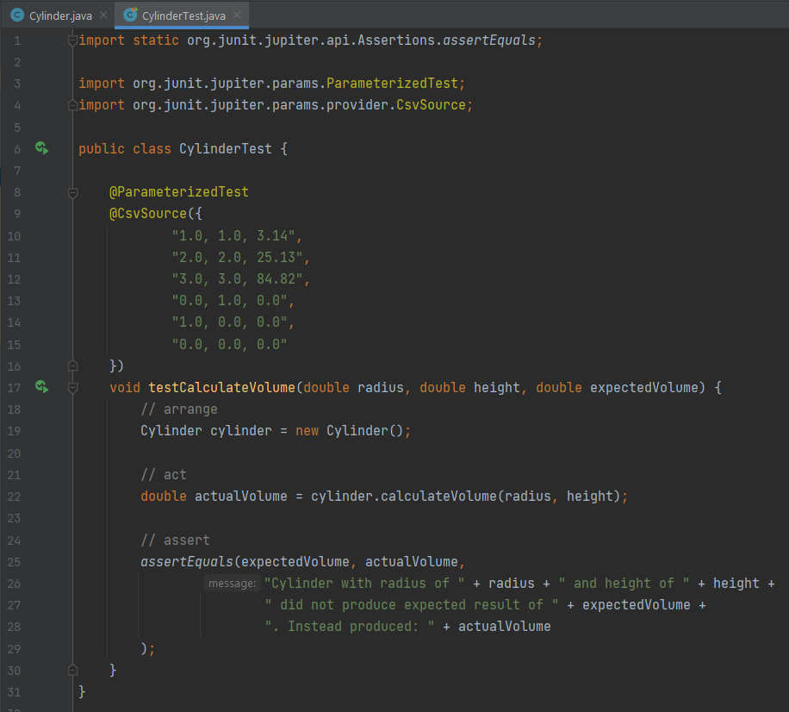
Code Listing 2 - Parameterised Test for calculateVolume
There are two new annotations to be introduced at this point: @ParameterizedTest and @CsvSource.
Key Term – @ParameterizedTest
The @ParameterizedTest annotation (note the US spelling that uses ‘z’), denotes a test method that replaces a standard test with multiple instances that run with different arguments, effectively executing the same test logic with multiple sets of data.

The @ParameterizedTest annotation is used instead of the normal @Test annotation. This denotes the test method will now accept parameters – in this case, the testCalculateVolume method accepts three parameters – radius, height, and expectedVolume (what we expect the result to be).
Key Term – @CsvSource
The @CsvSource annotation allows us to provide comma-separated values to be used as arguments in a parameterised test, allowing you to specify inline data sets directly in the test code.
The @CsvSource annotation is used to supply a list of values (as an array of strings) to the test method in the same order as the method’s parameter list. In the example of Code Listing 2, the first test can be read as “If I pass 1.0 in for the radius, and 1.0 for the height, I expect the volume to be 3.14”.
In the example of Code Listing 2, there are 6 tests. I’m sure you will agree that being able to condense provide the tests that we want to run as a list of strings is more convenient than creating individual test methods for each test case. We can also store these test cases in an external file (which would be more befitting of a CSV) – we’ll do this a little later. The output of running the parameterised test can be seen in Figure 1. Ensure you can fully reproduce these steps before continuing to the first exercise.

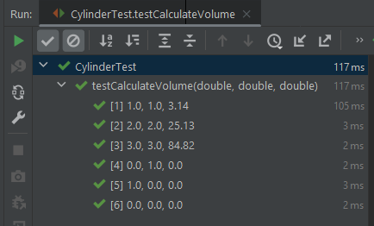
Figure 1 – ParamerterisedTest Output

Exercise 1 – Password Strength Checker
With your newly acquired knowledge of how tests can be parameterised, create a parameterised test to test the PasswordCheck.java class (available on Moodle).
Task Description: Passwords can be classified as being ‘weak’, ‘average’, or ‘strong’ based on different criteria. Download PasswordCheck.java from Moodle and add it into your project’s src folder, and create a parameterised test to demonstrate the rules in Table 1 are accurately implemented.
Notes: (1) you should focus your testing on the assessPasswordStrength method which accepts a String as a Password, (2) The assessPasswordStrength method is static – so you don’t need to create an object of the PasswordChecker class in order to call this method. If you are completely lost as to how this should be implemented, some starter code is provided in Appendix A.
Table 1 - Password Strength Rules
Password Strength | Rules for Password Strength | Example Passwords
Weak | Password should have a minimum length of less than 8 characters.  Password does not contain at least one uppercase letter.  Password does not contain at least one lowercase letter  Password does not contain at least one special character. | "abc", "12345678"
Average | Password has a minimum length of 8 characters or more.  Password contains at least one uppercase letter.  Password contains at least one lowercase letter.  Password does not contain at least one special character. | "Abcdefgh", "Hello123"
Strong | Password has a minimum length of 8 characters or more.  Password contains at least one uppercase letter.  Password contains at least one lowercase letter.  Password contains at least one special character. | "Strong@123", "P@ssw0rd"

Utilising External Data Sources
After completing the previous exercise, one observation you may have had is that even though we have saved time by providing multiple test inputs to a single parameterised method, we have provided these inputs in-line within the code. As you can imagine, if we have dozens of test cases to execute and use a single parameterised test to execute them, the code is quickly going to become hard to navigate, as all of our test data is bundled together with our test method.
Key Term – @CsvFileSource
The @CsvFileSource annotation in JUnit is used to provide test data for parameterised tests from an external CSV file. It allows you to separate your test data from your test code, making it easier to manage and update test data independently, especially when dealing with a large amount of test data or when the data is subject to frequent changes.
One way of remedying this is to have a clear separation of the test method and the data we want to pass to it. We saw in the previous exercise how we can use a @CsvSource to denote comma-separated input values, and we can use a similar annotation - @CsvFileSource – to denote that our test data is going to come from a dedicated CSV file.

Let’s look at an example of how this can be achieved. Returning to the walkthrough example that preceded Exercise 1, we had a Cylinder class which contained a method to calculate its volume. We will now create a dedicated CSV file for storing all of the tests we intend to execute and ‘hook up’ this CSV file to the test method.

Steps:
- Any external data sources (such as a CSV file that will contain our test data), need to be stored in a special folder (similar to how our tests are stored in the test folder). This folder will contain our Test Resources. Let’s create ths now.
  - Right-click your test folder and select New > Package (Figure 2). Name the package ‘resources’

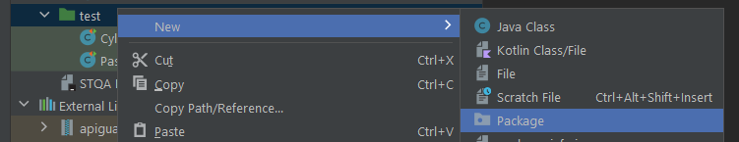
Figure 2 - Creating a New Package within our 'test' folder
- After the ‘resources’ package has been created, we now need to explicitly tell IntelliJ that our resources for testing are stored in this folder.
  - Click on File > Project Structure > Modules (left sidebar) > STQA Lab 3B (or whatever you called your project) > Sources Tab > Expand the green test folder so you can see the ‘resources’ package’ > Select the ‘resources’ package > Select “Mark as: Test Resources” > Press OK. That’s quite a lot of steps, so refer to Figure 3 for guidance.
  - If you have done this correctly, your ‘resources’ package in your test folder should look like: 
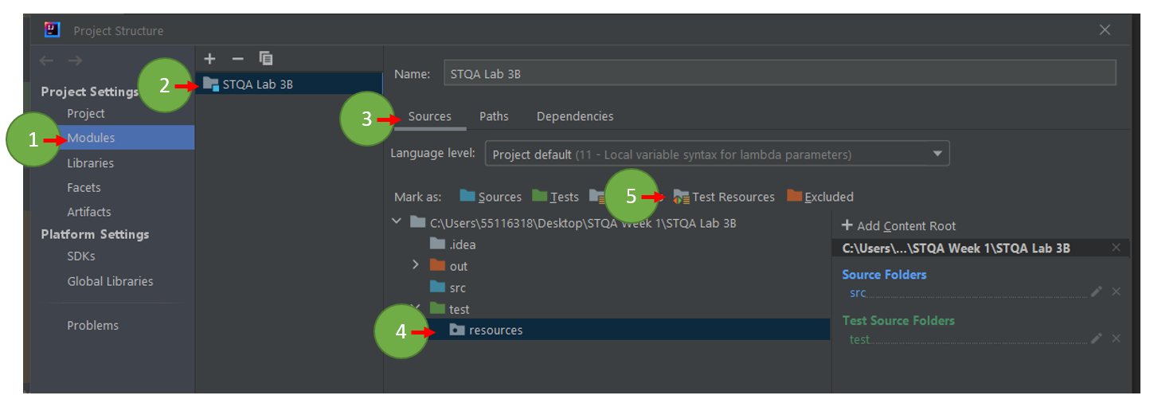
Figure 3 – Project Structure Window -> Navigating to set up Test Resources Folder
- The next step is to create the CSV that is going to store your test data. You can have multiple CSV files (e.g. one to test a testCalculateVolume method that contains all the tests we intend to execute, and then another CSV file for a completely different test method).
  - We can either create a CSV file manually using Excel, and type some values in the cells and save the file as a .csv, or we can create the file within IntelliJ itself. I’ll show the second option.
  - Right-click your ‘resources’ folder and select New > File and give it a suitable name (e.g. calculateVolume.csv).
  - We can then enter in our test cases from earlier, as depicted in Figure 4:
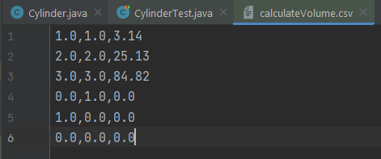
Figure 4 – calculateVolume.csv file contents
- With our CSV file created, we can now modify the test method to make use of it. Figure 5 illustrates how this can be achieved.

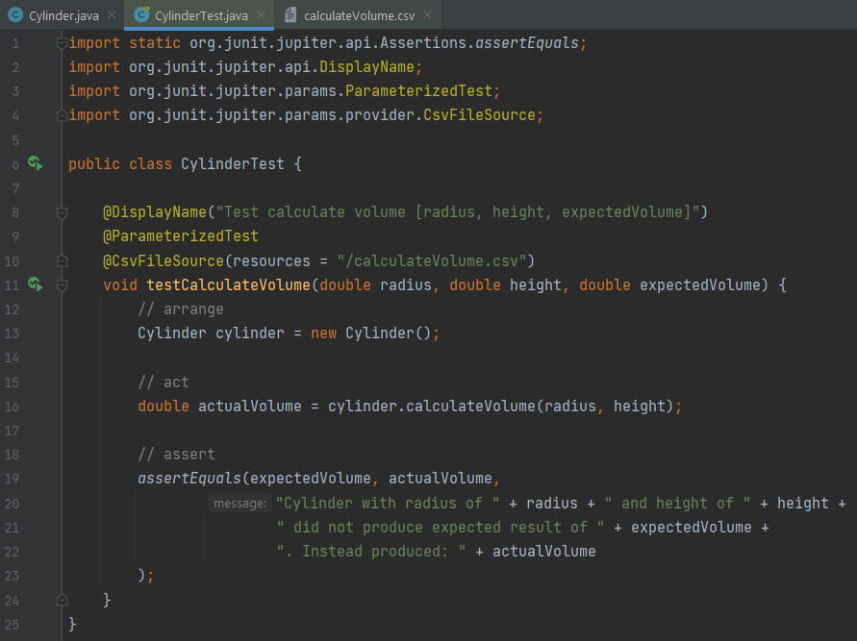
Figure 5 Implementing a @CsvFileSource parameterised test with an external CSV file
Note that you will need to import the @CsvFileSource annotation as you have to do with others – sometimes IntelliJ will do this for you automatically.

Exercise 2 – Refactoring Password Strength Checker
Refactor your code from Exercise 1 so that it utilises a CSV file to store and execute the tests instead of having the test case in-line.

Lab Summary
This lab has been different to previous ones – we have introduced brand new content in the lab sheet itself, so do not feel dismayed if you do not yet have a full grasp on how these concepts work – you still have time to reinforce these concepts before you write and execute tests on the assignment system.
In this lab, we explored parameterised testing in JUnit, a powerful testing feature that allows us to write more versatile and concise tests by running the same test logic with multiple sets of input data. We focused on using the @ParameterizedTest annotation and learned about two common ways to provide test data: @CsvSource and @CsvFileSource.

Key Takeaways:
@ParameterizedTest Annotation:
The @ParameterizedTest annotation allows us to create parameterized test methods, which can take multiple sets of input data.
It simplifies writing repetitive test methods for different input scenarios.

@CsvSource:
The @CsvSource annotation is used to provide test data directly within the test code.
It takes comma-separated values (CSV) as input, where each line represents a set of input parameters and their expected output.

@CsvFileSource:
The @CsvFileSource annotation allows us to provide test data from an external CSV file.
It separates test data from test code, making it easier to manage large datasets and maintainability of tests.

Appendix A – Starter Code

PasswordChecker Starter Code for Testing

Note: the code below only contains two tests – you would need to add quite a few more
import static org.junit.jupiter.api.Assertions.*;
import org.junit.jupiter.api.Test;
import org.junit.jupiter.params.ParameterizedTest;
import org.junit.jupiter.params.provider.CsvSource;
import static org.junit.jupiter.api.Assertions.assertEquals;
public class PasswordCheckerTest {
@ParameterizedTest
@CsvSource({
// Test case: Password length is less than 8 characters, no uppercase, lowercase, or special char
"abc, Weak",
// Test case: Password length is exactly 8 characters, no uppercase, lowercase, or special char
"12345678, Weak"
})
public void testAssessPasswordStrength(String password, String expectedStrength) {
String actualStrength = PasswordChecker.assessPasswordStrength(password);
assertEquals(expectedStrength, actualStrength);
}
}

